OSSP (Operating Systems and Systems Programming) – 25CS2104E
OSSP LAB – PRACTICAL-WEEK 1
Aim
To develop a C program that accepts a Linux command from the user, creates a child process using fork(), executes the command using execvp(), waits for the child process to complete using wait(), and displays the Process IDs (PIDs) of both the parent and child processes

Algorithm
- Start the program.
- Read a Linux command from the user.
- Split the command into the command and its arguments.
- Call fork() to create a child process.
- If it is the child process:
- Display the Child Process ID (PID).
- Execute the command using execvp().
- If it is the parent process:
- Display the Parent Process ID (PID).
- Wait for the child process to finish using wait().
- Print the completion message.
- End the program.

Step 1: Open ubuntu and Create a C file
nano task1.c
Step 2: Code
#include <stdio.h>
#include <stdlib.h>
#include <unistd.h>
#include <sys/wait.h>
int main()
{
char command[100];
printf("Enter a Linux command: ");
scanf("%s", command);
pid_t pid = fork();
if(pid < 0)
{
printf("Fork Failed!\n");
return 1;
}
else if(pid == 0)
{
printf("\nChild Process\n");
printf("Child PID : %d\n", getpid());
execlp(command, command, NULL);
printf("Command execution failed.\n");
}
else
{
printf("\nParent Process\n");
printf("Parent PID : %d\n", getpid());
wait(NULL);
printf("Child process completed.\n");
}
return 0;
}

Step 4: Save the file
Cltr+o
Enter
Cltr+x

Step 5:Compile the program
gcc task1.c -o task1

Step 6: Run the program
./task1

Using Linux terminal commands (uname , lscpu , lsblk , ps , top)
- Enter a Linux command : uname
Displays the Linux kernel name, version, machine architecture, and operating system details.
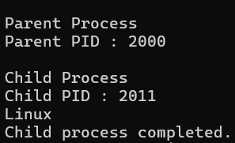

- Enter a Linux command : lscpu
Displays CPU architecture, number of processors, cores, threads, cache size, and virtualization support.
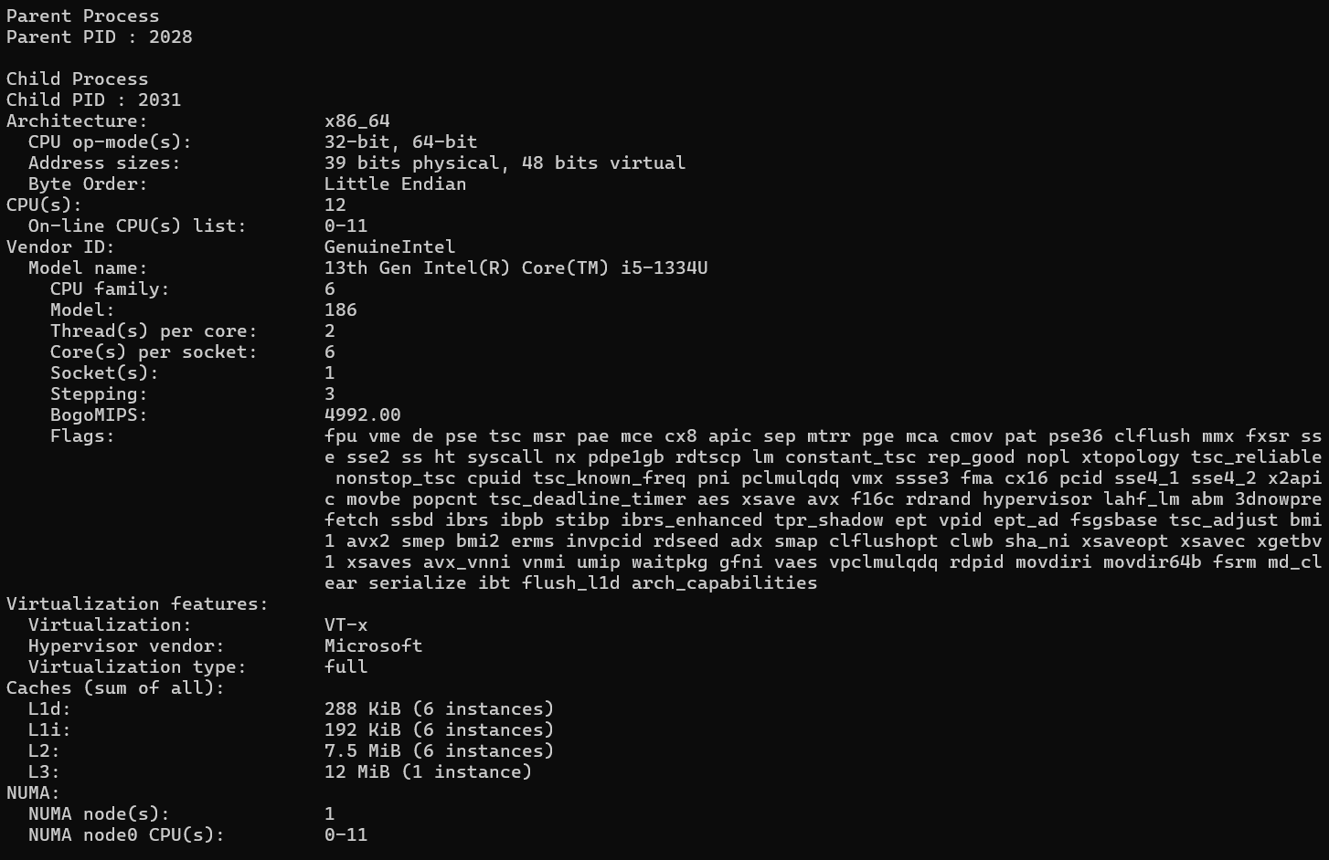
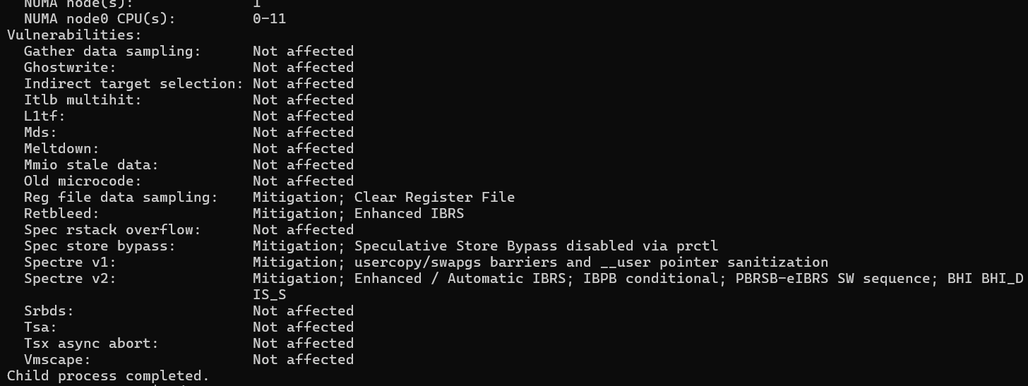

- Enter a Linux command : lsblk
Lists all storage devices such as hard disks, SSDs, USB drives, and their partitions.
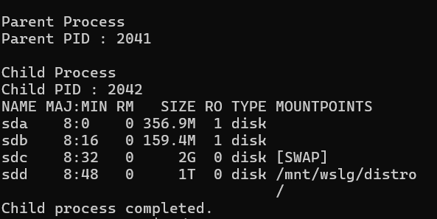

- Enter a Linux command : ps
Displays all currently running processes along with their Process IDs (PID).
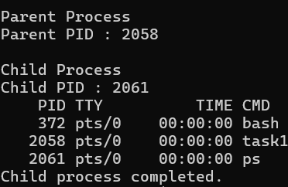

- Enter a Linux command : top
Displays real-time information about CPU usage, memory usage, running processes, and system load.
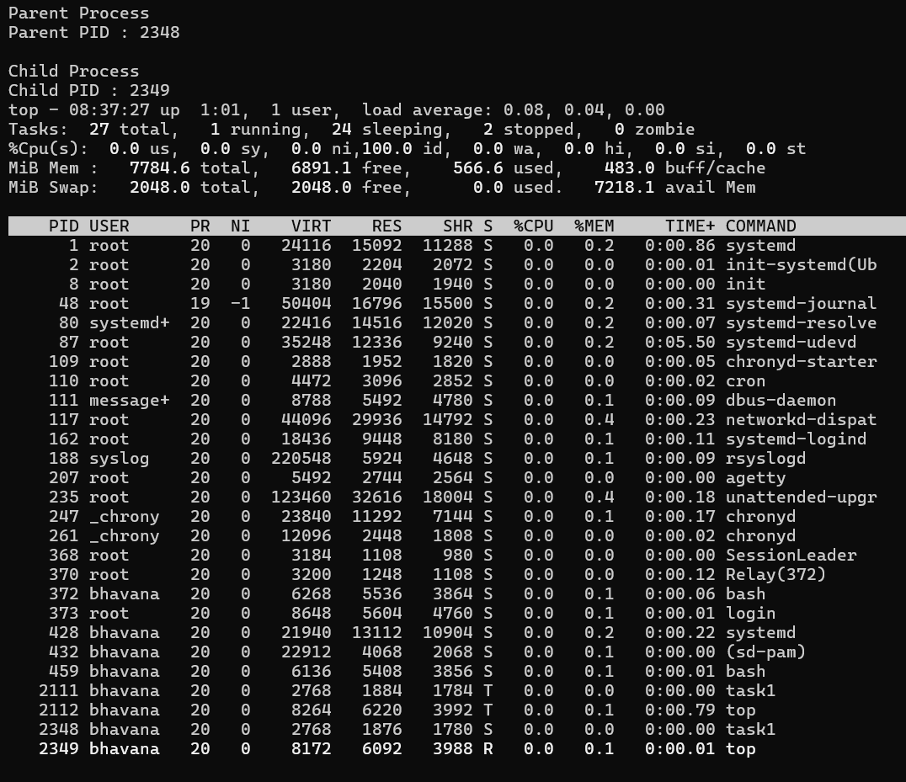

Conclusion
Linux abstracts hardware resources by providing a simple interface between applications and physical hardware. It efficiently manages CPU scheduling, memory allocation, storage devices, and I/O operations through system services, allowing multiple programs to run safely and efficiently without directly interacting with the hardware.

